1. CREATE USER DELOITTE IDENTIFIED BY deloitte;
2. ALTER USER DELOITTE IDENTIFIED BY DELOITTE;
3. 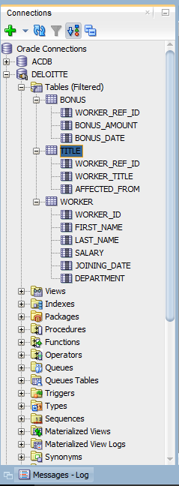
4. SELECT FIRST_NAME AS WORKER_NAME FROM WORKER;
5. SELECT UPPER(FIRST_NAME) FROM WORKER;
6. SELECT DISTINCT DEPARTMENT FROM WORKER;
7. SELECT INSTR(FIRST_NAME,'A')

FROM WORKER

WHERE FIRST_NAME='Amitabh';

1. SELECT SUBSTR(FIRST_NAME,1,3)

FROM WORKER;

1. SELECT RTRIM(FIRST_NAME)

FROM WORKER;

1. SELECT LTRIM(DEPARTMENT)

FROM WORKER;

1. SELECT distinct DEPARTMENT, length(department)

FROM WORKER;

1. SELECT REPLACE(FIRST_NAME,'A','a')

FROM WORKER;

1. SELECT FIRST_NAME || ' ' || LAST_NAME AS COMPLETE_NAME

FROM WORKER;

1. SELECT *

FROM WORKER

ORDER BY FIRST_NAME;

1. SELECT *

FROM WORKER

ORDER BY FIRST_NAME,DEPARTMENT DESC;

1. SELECT *

FROM WORKER

WHERE

FIRST_NAME='Vipul'

OR

FIRST_NAME='Satish';

1. SELECT *

FROM WORKER

WHERE

FIRST_NAME!='Vipul'

OR

FIRST_NAME!='Satish';

1. SELECT *

FROM WORKER

WHERE

DEPARTMENT = 'Admin';

1. SELECT *

FROM WORKER

WHERE

first_name like '%a%';

1. SELECT *

FROM WORKER

WHERE

first_name like '%a';

1. SELECT *

FROM WORKER

WHERE

first_name like '%h'

and length(first_name)=6;

1. SET SERVEROUTPUT ON;

DECLARE

V_MAX_DEPTNO NUMBER;

BEGIN

SELECT MAX(DEPARTMENT_ID)

INTO V_MAX_DEPTNO

FROM TBLDEPARTMENTS ;

DBMS_OUTPUT.PUT_LINE('MAXIMUM DEPARTMENT ID '|| V_MAX_DEPTNO);

END;

1. SET SERVEROUTPUT ON;

DECLARE

"ALTER" NUMBER :=2;

BEGIN

DBMS_OUTPUT.PUT_LINE("ALTER");

END;

1. SET SERVEROUTPUT ON;

DECLARE

A NUMBER :=2;

B VARCHAR2(5):='BLUE';

BEGIN

DBMS_OUTPUT.PUT_LINE(A);

DBMS_OUTPUT.PUT_LINE(B);

DECLARE

A NUMBER:=3;

B VARCHAR2(5):='RED';

BEGIN

DBMS_OUTPUT.PUT_LINE(A);

DBMS_OUTPUT.PUT_LINE(B);

END;

DBMS_OUTPUT.PUT_LINE(A);

DBMS_OUTPUT.PUT_LINE(B);

END;

1. SET SERVEROUTPUT ON;

DECLARE

V_SALARY NUMBER(10,2);

BEGIN

SELECT SALARY INTO V_SALARY

FROM TBLEMPLOYEES

WHERE EMPLOYEE_ID=110;

V_SALARY:=V_SALARY+ V_SALARY*0.50;

DBMS_OUTPUT.PUT_LINE(V_SALARY);

END;